

SOCIAL NETWORK ANALYSIS PROJECT

Prof. Shivraj Kanungo

**Question of Interest**

There is no doubt that the Oscar Academy Award Ceremony is one of the biggest events throughout the year. It once again drew the world’s attention as the 90th Oscar Award Ceremony successfully landed in Los Angeles on March 4th. The focus of the topic is always about the Oscar Winning Actors and Actress and we are so amazed at how successful, famous and popular they are on and off stage. So the topic of movie actors also become the interest of our analysis.

People not only talk about these successful actors and their marvelous work in film industry, they are also very interested in their colorful personal life and their mysterious social network. How many peer actor friends do they have and are they also popular among them? How many important directors and writers are they connected with and does the relationship help them with their career?

These are all the questions we are super curious about. That’s how our driving question of our analysis came out: How does actors’ social network relate to their success?

To analyze this problem, we selected two groups of people in the film industry that have a potential huge influence on the actors: Directors who direct films and Writers who make the film scripts. We also created different actors group with different success levels and then compared their social performance in the different social relations.

The overall network with actors, directors and writers looks like below.

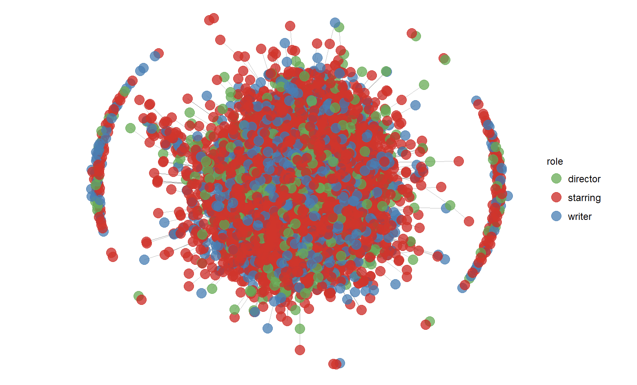

**Data Source**

We collected network data of actors-directors-writers from <https://aminer.org/data-sna#Movie> website. The source data consist of two sections, vertices and edges. The vertices section explains the node attributes and the edges section gives the information about ties between the nodes. Only one type of relation is used in the data set, which can be simplified as an undirected “knows” relationship, i.e. Actor X and Director Y know each other.

To download the dataset, click on the download link for movies dataset in the website mentioned above.

Additionally, we have used Wikipedia Oscar Best Actor/Actress List and IMDB Hollywood A-lister List to create a group of Oscar winners actors and a group of famous actors (not Oscar winners but are also popular and famous). The lists are not comprehensive list but serve our purpose of comparison.

**Our Network Analysis Approach**

The first part of our analysis is based on comparing three groups of actors (group 1- Oscars winners, group 2 - famous actors who are not Oscar winners but are also popular and famous and group 3 - all actors) in terms of different types centralities/importance in three different networks (actor-actor, actor-director and actor-writer networks). This comparative analysis among three groups will help determine whether actors’ sociability in the networks is actually one of the main reasons for their success in Oscar or popularity.

The second part of our analysis is focused on finding the most sociable directors and writers in the network and how many of these directors or writers are known by the actors from group 1, 2 and 3. The motive is to find out how each group differs in forming ties with most sociable or important directors and writers in the network.

**Results**

Firstly, we calculated the degree centrality, closeness centrality and betweenness centrality of all the actors from the network that consist of only actor-actor ties. We compared the descriptive statistics of different centralities among the group. Mean values are given in the below table to illustrate the difference between these groups.

|  |  |  |  |
| --- | --- | --- | --- |
| Group | Average Degree Centrality | Average Closeness Centrality | Average Betweenness Centrality |
| Oscar Winners | 37.8 | 6.644e-07 | 156447 |
| Famous Actors | 31.7 | 6.640e-07 | 103444 |
| All actors in the network | 6.9 | 6.444e-07 | 12518 |

To find out the importance/sociability of an actor in his/her social network we gave equal weight to all the three types of centralities and we also assigned an overall rank to each actor.

The results clearly show that ranks of actors from group 1 and group 2 are better than that of group 3. Oscar winners have higher average degree centrality, higher average betweenness centrality, and higher average closeness centrality compared to famous actors, and famous actors all have higher centrality compared to average centrality of all the actors. Please refer to below tables for more details on the results generated in r console.

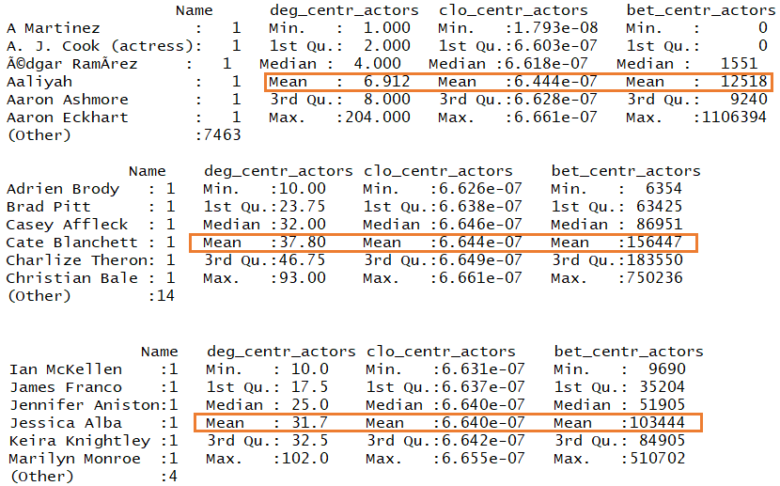

Descriptive statistics of different Centralities in actor-actor network

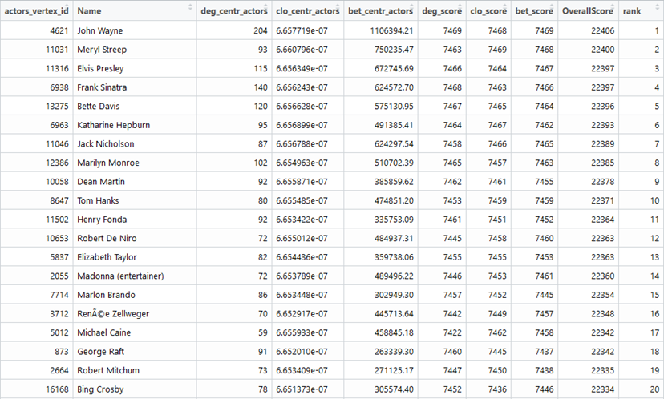

Ranks of all actors

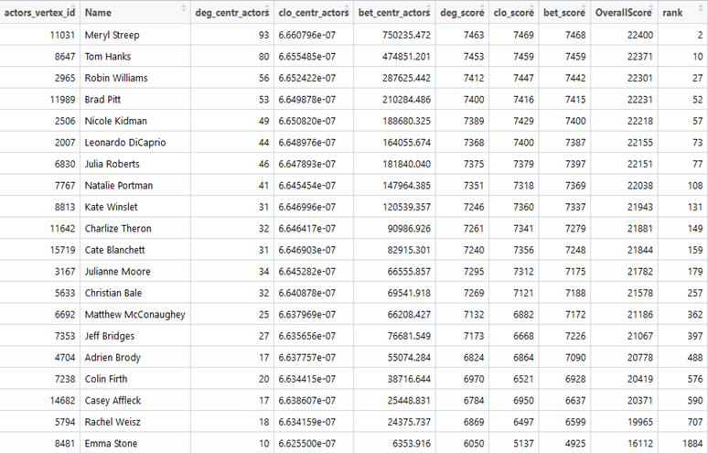

Ranks of Oscar winners

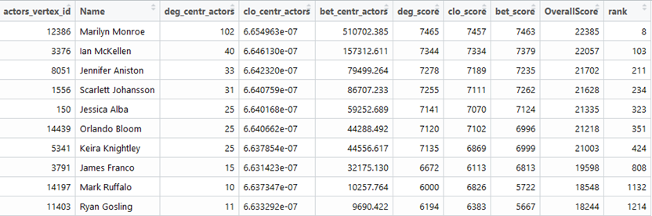

Ranks of famous actors

Then we calculated the degree centrality of all actors from the network that consist of only actor-director ties. We saw similar results as we saw in case of actor-actor network. The result that Oscar winners, on average know more directors than famous actors and famous actors on average know more directors than the average of all the actors. Mean values are given in the below table to illustrate the difference between these groups.

|  |  |
| --- | --- |
| Group | Mean Degree Centrality |
| Oscar Winners | 11.3 |
| Famous Actors | 8.50 |
| All actors in the network | 2.85 |

Please refer to below tables for more details on the the results generated in r console.

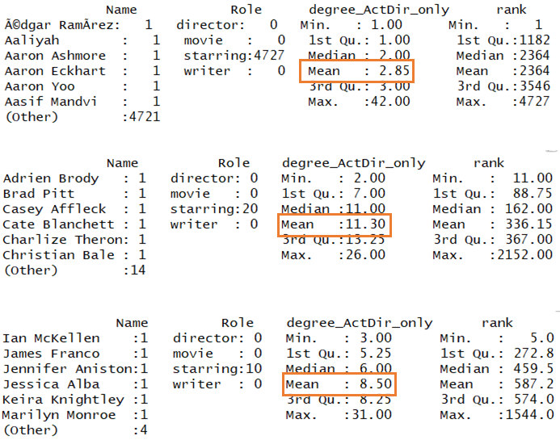

Descriptive statistics of different Centralities in actor-director network

We performed similar analysis on actor-writer network and the results were as expected. Oscar winners, on average know more writers than famous actors and famous actors on average know more writer than the average of all the actors. Mean values are given in the below table to illustrate the difference between these groups.

|  |  |
| --- | --- |
| Group | Mean Degree Centrality |
| Oscar Winners | 14.55 |
| Famous Actors | 8.3 |
| All actors in the network | 3.05 |

Please refer to the below tables for more details on the results for the results generated in r console.

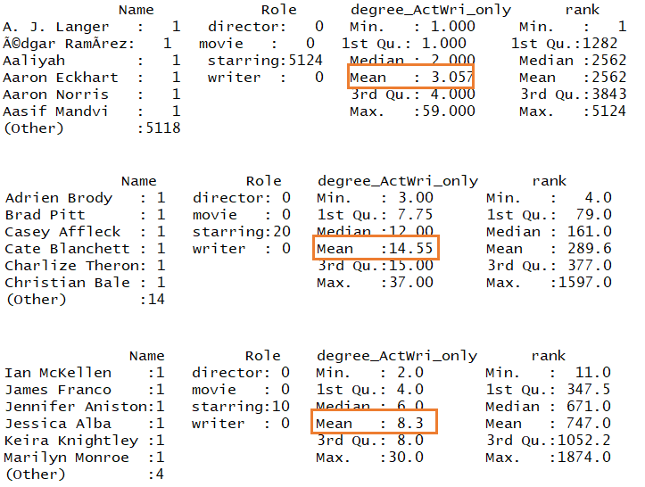

Descriptive statistics of different Centralities in actor-writer network

In the second part of our analysis, we initially identified most sociable/important directors and writers in the network. To identify most sociable/important directors and writers, we calculated the degree centrality, closeness centrality and betweenness centrality of all the directors and writers in whole network and assigned ranks to them by giving equal weight to all the centralities. An ordered (based on rank) list of top 20 important directors and writers is shown on the below screenshot.

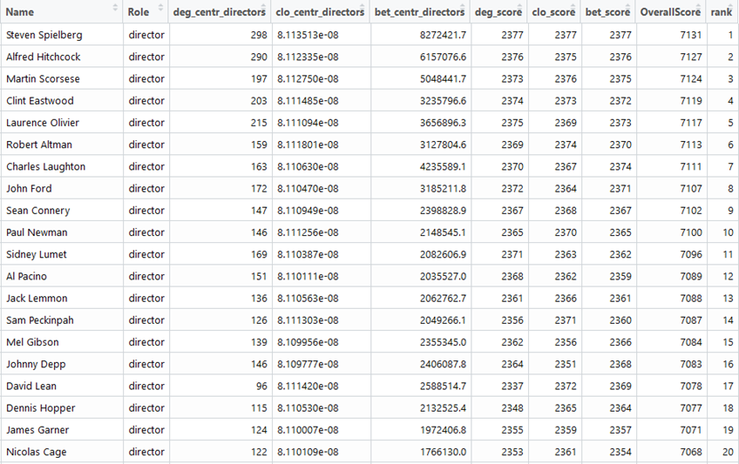

List of important/sociable directors in the whole network

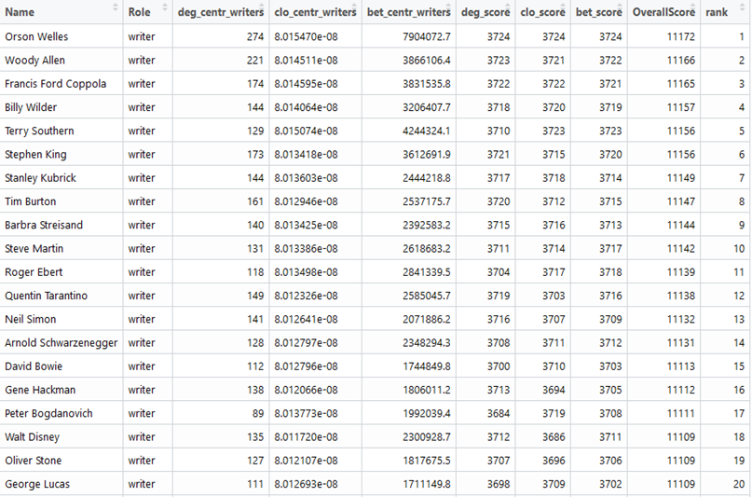

List of important/sociable writer in the whole network

Finally, we calculated the average important directors and writers each group knows. As we can see from the below tables that Oscar winners know more important directors and writers than other groups. This result proves that Oscar winners and famous actors not only knows more people in the network, they also know more important people, which may relate to their success in the film industry.

|  |  |
| --- | --- |
| Groups | Mean |
| Oscar Winners | 4.9 |
| Famous Actors | 3.3 |
| All the Actors | 1.6 |

|  |  |
| --- | --- |
| Groups | Mean |
| Oscar Winners | 4.1 |
| Famous Actors | 2.1 |
| All the Actors | 1.6 |

**Conclusion**

* Oscar winners are more sociable among actors, writers and directors and they know more big names than famous actors.
* Famous actors are more sociable among actors, writers and directors and they know more big names comparing to the average of the average of the whole actor population.
* An actor’s success is highly related to the number of people in the film industry they know and the number of important people in the industry they know.